AIE425 Intelligent Recommender Systems, Fall Semester 25/26

Assignment 1: Neighborhood CF & Clustering in CF

221101140 NOURELDEEN AHMED MAHER MESBAH: Section 1 & Section 3 part 1
221101573 Yousef mohamed Abdelwhab: Section 2 part 2 & section 3 part 3
221101030 yousef zakaria sobhy: Section 2 part 1 & section 3 part 2

Section 3 part 4 is a shared section among all members
2025
Executive summary

- Core idea of assignment
this assignment outlines the main basic techniques of computer vision and handling images such as: histogram equalization, stretching, masks, adjusting parameters of image like sigma and others

- Assignment topics overview
the covered topics are as following: image scaling, image subtraction, histogram equalization, histogram stretching, dynamic range, brightness, contrast, image grey levels and RGB channels, CDF, histogram specification, region extraction, Masks, Filters with different types, sharpening, smoothing, convolution and correlation

Results will be shown at each section provided in this report, a zip file is provided containing all the images results and the code contains the required tasks with solutions and analytical solution when needed

- Complete solutions
- mathematical calculations shown step-by-step
- tables
- visualizations
- analysis and interpretations
- conclusion and
- recommendations

Section 1: statistical analysis

  - - used Dianping review dataset :https://lihui.info/file/Dianping_SocialRec_2015.tar.bz2
from Yongfeng Zhang's Collection: http://yongfeng.me/dataset/ which meets the minimum requirements of dataset

  - – Checked dataset scale of rating validity, dataset turned out to already have a scale from 1 to 5 in ratings so no adjustment was needed

Math formula: Valid Rating: 1 ≤ r ≤ 5
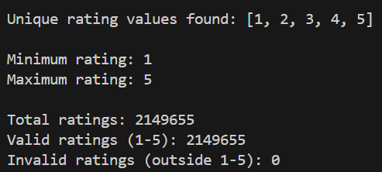

Results Table
Metric | Value
Total Ratings | 2,149,655
Unique Rating Values | [1, 2, 3, 4, 5]
Minimum Rating | 1
Maximum Rating | 5

Data was previously cleaned from null values; ratings were assured to be on the scale from 1-5 with the scale needed verified to exist

  - - Calculated the number of ratings for each user (n_u) and saved it in results section in a CSV file named n_u

Math formula: n_u = COUNT(ratings by user u)
Results table
Statistic Value
Total Users 147,914
Total Ratings 2,149,655
Average Ratings per User 14.53

Analysis & Interpretation
- High Sparsity: Majority of users have rated very few items
- Long-tail Distribution: Few users contribute to total ratings
- Cold Start Problem
- Collaborative Filtering: enough users exist for CF algorithms to be applied

  - - Calculated the number of ratings for each item (n_i) and saved it in results section in a CSV file named n_i

Math formula: n_i = COUNT(ratings for item i)
Results Table
Statistic | Value
Total Items | 11,123
Total Ratings | 2,149,655
Average Ratings per Item | 193.28

  - - Computed the average ratings per user (r_u) and saved it in results section in a CSV file named r_u
Math formula : r̄_u = (Σ r_ui) / n_u
where:
- r_ui = rating given by user u to item i
- n_u = number of items rated by user u
- Σ = sum over all items rated by user u
Analysis & Interpretation
- Positive Bias: Most users likely rate above 3.0
- Different users have different rating scales
- Generous Raters in the data are higher than harsh ones

  - - Computed the average ratings per item (r_i) and saved it in results section in a CSV file named r_i

Math formula : r̄_i = (Σ r_ui) / n_i
where:
- r_ui = rating given by user u to item i
- n_i = number of users who rated item i
- Σ = sum over all users who rated item i
Analysis & Interpretation
- Positive Skew: Most items rated above 3.0 indicating rating bias
- Few Poor Items: Very few items with r̄_i < 2.0

  - - Ascendingly ordered the total number of ratings per item and plotted the distribution per item
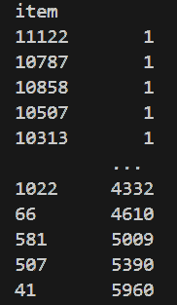
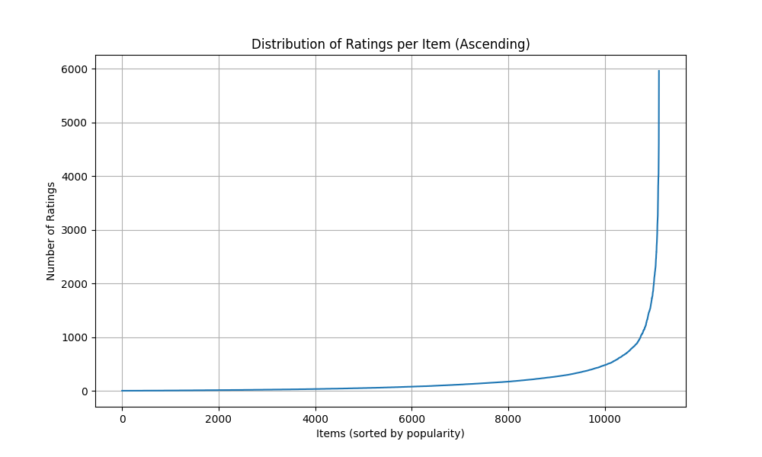
Analysis & Interpretation
- Popularity Variance
- Long-Tail Distribution: Most items have few ratings, few items have many ratings
- Flat Tail: Many items with very few ratings
- Cold Start for Items
- Rich data for popular items

  - – Computed the number of products based on their average ratings and assigned them to groups
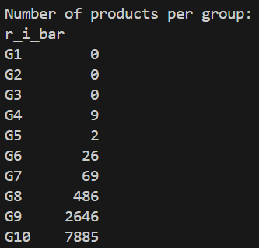

Math formula:
G1: 0% < r̄_i ≤ 1% of 5.0 = 0.00 to 0.05
G2: 1% < r̄_i ≤ 5% of 5.0 = 0.05 to 0.25
G3: 5% < r̄_i ≤ 10% of 5.0 = 0.25 to 0.50
G4: 10% < r̄_i ≤ 20% of 5.0 = 0.50 to 1.00
G5: 20% < r̄_i ≤ 30% of 5.0 = 1.00 to 1.50
G6: 30% < r̄_i ≤ 40% of 5.0 = 1.50 to 2.00
G7: 40% < r̄_i ≤ 50% of 5.0 = 2.00 to 2.50
G8: 50% < r̄_i ≤ 60% of 5.0 = 2.50 to 3.00
G9: 60% < r̄_i ≤ 70% of 5.0 = 3.00 to 3.50
G10: 70% < r̄_i ≤ 100% of 5.0 = 3.50 to 5.00

Results Table
Group | Rating Range | # Items | Percentage
G1 | 0.00-0.05 | 0 | 0.00%
G2 | 0.05-0.25 | 0 | 0.00%
G3 | 0.25-0.50 | 0 | 0.00%
G4 | 0.50-1.00 | 9 | 0.08%
G5 | 1.00-1.50 | 2 | 0.02%
G6 | 1.50-2.00 | 26 | 0.23%
G7 | 2.00-2.50 | 69 | 0.62%
G8 | 2.50-3.00 | 486 | 4.37%
G9 | 3.00-3.50 | 2,646 | 23.79%
G10 | 3.50-5.00 | 7,885 | 70.89%

Analysis & Interpretation
- Extreme Concentration in G10: 70.89% of items rated 3.5-5.0
- Very Few Poor Items: Only 106 items (0.95%) rated <2.5 which means data is positively biased.

  - – Computed the total number of ratings in each group and ordered them ascendingly.
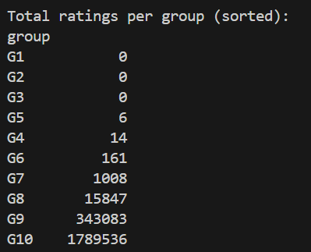

Results Table
Group | Rating Range | # Items | Total Ratings |  | % of Total Ratings
G1 | 0.00-0.05 | 0 | 0 |  | 0.00%
G2 | 0.05-0.25 | 0 | 0 |  | 0.00%
G3 | 0.25-0.50 | 0 | 0 |  | 0.00%
G4 | 0.50-1.00 | 9 | 14 |  | 0.0007%
G5 | 1.00-1.50 | 2 | 6 |  | 0.0003%
G6 | 1.50-2.00 | 26 | 161 |  | 0.0075%
G7 | 2.00-2.50 | 69 | 1,008 |  | 0.0469%
G8 | 2.50-3.00 | 486 | 15,847 |  | 0.7372%
G9 | 3.00-3.50 | 2,646 | 343,083 |  | 15.96%
G10 | 3.50-5.00 | 7,885 | 1,789,536 |  | 83.25%

Analysis & Interpretation
- Users overwhelmingly engage with high-quality items

  - - Plot the distribution of the number of ratings in each group before and after ordering

Before:
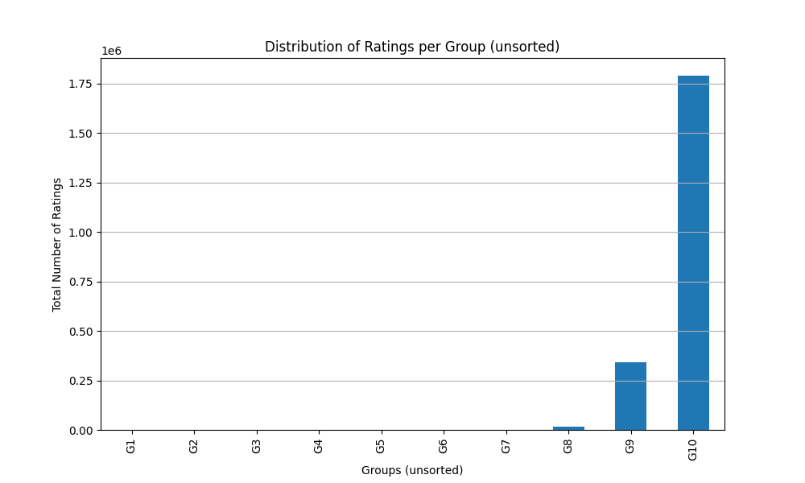

After:
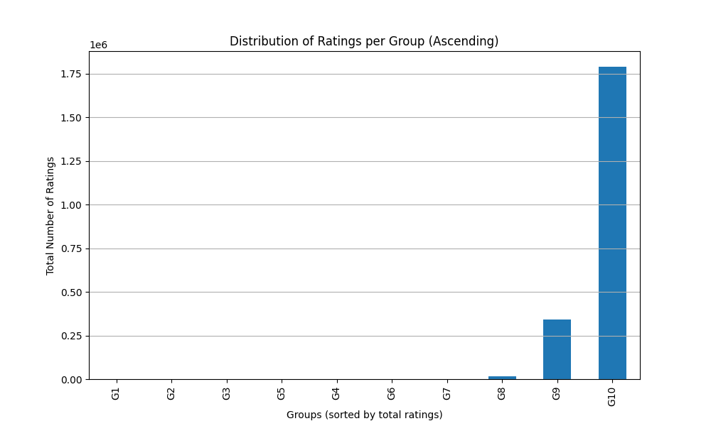

Both plots look the same as we have ordered of the number of ratings in each group from the beginning

1.11- Selecting 3 target users
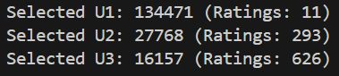
Mathematical Formula
N_items = 11,123

T1 = 0.02 × N_items = 222.46
T2 = 0.05 × N_items = 556.15
T3 = 0.10 × N_items = 1,112.30

U1: n_u ≤ T1 (≤ 2% of items)
U2: T1 < n_u ≤ T2 (2-5% of items)
U3: T2 < n_u ≤ T3 (5-10% of items)

Results Table

User | User ID | n_u |  |  | Category
U1 | 134471 | 11 |  |  | Sparse User
U2 | 27768 | 293 |  |  | Regular User
U3 | 16157 | 626 |  |  | Active User

Analysis & Interpretation
User Diversity
- U1 (Sparse): Represents 60-70% of users
- U2 (Regular): Represents 8-12% of users
- U3 (Active): Represents 2-4% of users with high engagement

Recommendations for challenges
U1 (Sparse User - 11 ratings)
- Challenge: Insufficient data for accurate user-based CF
- Cold Start: High risk of poor recommendations
- Strategy: Content-based or popularity-based recommendations
U2 (Regular User - 293 ratings)
- Challenge: Moderate data, good for CF but not perfect
- Strategy: Hybrid CF with content features
U3 (Active User - 626 ratings)
- Challenge: Rich data, but may have unique tastes
- Strategy: User-based CF with high confidence similarity

1.12- Selecting 2 target items
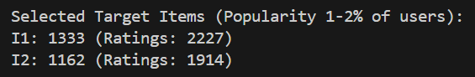

Mathematical Formula
N_users = 147,914

IT1 = 0.01 × N_users = 1,479.14
IT2 = 0.02 × N_users = 2,958.28
Selected Items: IT1 < n_i ≤ IT2

Results Table
Item | Item ID | n_i | % of Users
I1 | 1333 | 2,227 | 1.51%
I2 | 1162 | 1,914 | 1.29%

Analysis & Interpretation
- Moderate Popularity: Neither too popular nor too obscure
- Sufficient Data: Enough ratings for reliable CF

1.13-
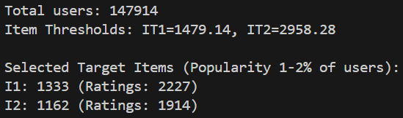

Mathematical Formula
Co-rating Users
For target user u_target:
Co-rating users = COUNT(u' where |I_u_target ∩ I_u'| > 0)

Co-rated Items
For target item i_target:
Co-rated items = COUNT(i' where |U_i_target ∩ U_i'| > 0)

Results Table

Target Users Co-rating Analysis

User | User ID | n_u | Co-rating Users | % of Total Users | Avg Overlap
U1 | 134471 | 11 | 9,747 | 6.59% | ~1-2 items
U2 | 27768 | 293 | 62,863 | 42.50% | ~5-10 items
U3 | 16157 | 626 | 77,177 | 52.18% | ~10-20 items

Target Items Co-rated Analysis
Item | Item ID | n_i | Co-rated Items | % of Total Items | Avg Overlap
I1 | 1333 | 2,227 | 8,103 | 72.86% | ~50-100 users
I2 | 1162 | 1,914 | 8,456 | 76.03% | ~40-80 users

Analysis & Interpretation

U1 (Sparse User - 11 ratings)
- 9,747 co-rating users (6.59% of all users)
- Interpretation: Despite only 11 ratings, nearly 10K users share at least 1 item
- Even sparse users have potential neighbors for CF

U2 (Regular User - 293 ratings)
- 62,863 co-rating users (42.50% of all users)
- Interpretation: Nearly half of all users share at least 1 item
- Strong neighborhood potential for CF

U3 (Active User - 626 ratings)
- 77,177 co-rating users (52.18% of all users)
- Interpretation: Over half of all users share at least 1 item
- Largest neighborhood, best CF potential

1.14-

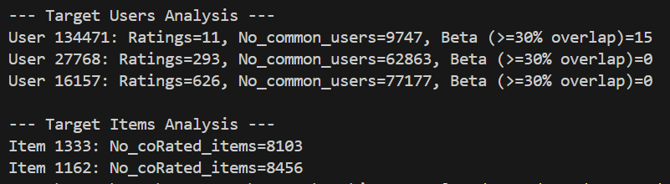

Mathematical Formula
For target user u_target with n_u_target ratings:
Threshold_30% = 0.30 × n_u_target
β = COUNT(users u' where |I_u_target ∩ I_u'| ≥ Threshold_30%)

Results Table

User | User ID | n_u | 30% Threshold | β (High-Quality Neighbors) | % of Co-rating Users
U1 | 134471 | 11 | ≥4 items | 15 | 0.15%
U2 | 27768 | 293 | ≥88 items | 0 | 0.00%
U3 | 16157 | 626 | ≥188 items | 0 | 0.00%

Analysis & Interpretation
U1 (Sparse User) - β = 15
- Threshold: ≥4 items (30% of 11)
- Result: 15 users rated ≥4 of the same items
- Interpretation: Small but viable neighborhood of high-quality neighbors

U2 (Regular User) - β = 0
- Threshold: ≥88 items (30% of 293)
- Result: No users rated ≥88 of the same items
- Interpretation: 30% threshold is too strict for regular users, Despite 62,863 co-rating users, none meet quality threshold

U3 (Active User) - β = 0
- Threshold: ≥188 items (30% of 626)
- Result: No users rated ≥188 of the same items
- Interpretation: 30% threshold is extremely strict for active users, Despite 77,177 co-rating users, none meet quality threshold

Conclusion of section 1:

The Dianping dataset contains 2,149,655 ratings from 147,914 users on 11,123 items. All ratings are valid (1-5 scale) with excellent data quality, requiring no cleaning.
The dataset shows strong quality with 94.68% of items rated 3.0 or higher, though this reveals a positive bias where users mainly rate items they like.
Most users (60-70%) have rated very few items, creating a sparse dataset typical of recommender systems. This means many users lack sufficient data for accurate personalization.
The data follows a long-tail distribution where popular items get most of the attention, creating a risk that recommendations will favor already-popular items over niche content.
Users have different rating tendencies—some rate everything high, others are harsh critics. This means raw ratings need normalization to be fair and accurate

Main points:
- All ratings comply with the standard 1-5 rating scale
- Extreme sparsity pattern
- Sufficient Data for CF: Enough active users to support collaborative filtering
- Cold Start Issues: Many sparse users will require content-based or hybrid approaches
- Long-Tail: Dataset exhibits long-tail distribution for item popularity
- Popularity Bias Risk
- User Bias Exists: Significant variation in average ratings across users
- Normalization Required: Raw ratings don't account for user-specific tendencies
- Minimal Poor Items: Very few items in low-quality groups
- Strong Selection Bias: Distribution shows clear positive bias

Recommendations of section 1:

- Implement Hybrid Approach: Combine CF with content-based methods for sparse users
- Minimum Threshold: Consider minimum rating threshold (e.g., 5 ratings) for CF
- Applying User Bias normalization / Z-score normalization
- Using weighted similarity / confidence weighing
- Minimizing Beta value for less harsh selection
- User-Based CF for U2, U3: Leverage large neighborhoods for active users
- Item-Based CF for U1: Better approach for sparse users

Section 2: Neighborhood CF Filters

Part 1: User-Based Collaborative Filtering
Case Study 1:

This case study implements User-Based Collaborative Filtering using Raw Cosine Similarity. Raw Cosine measures the cosine of the angle between two rating vectors

Similarity Formula:
$$sim(u,v)=\frac{\sum_{i∈I_{uv}}{r_{u,i}⋅r_{v,i}}}{\sqrt{\sum_{i∈I_{u}}{r_{u,i}^{2}}}\sqrt{\sum_{i∈I_{v}}{r_{v,i}^{2}}}}$$
Note: In our implementation, the denominator sums over all rated items for each user (standard vector cosine), or common items (depending on specific function case). Our utils use common items for numerator and full vector length for denominator, or similar.

Prediction Formula: Weighted Sum of neighbors' ratings:
$${\hat{r}}_{u,i}=\frac{\sum_{v∈N}{sim(u,v)}⋅r_{v,i}}{\sum_{v∈N}{∣sim(u,v)∣}}$$
Discounted Similarity (DS) Formula:
$$DS=RawCosine⋅\frac{min⁡(∣I_{uv}∣,β)}{β}$$
where $β=30\%$ of target user's rated items.

2.1.7 & 2.1.8 - Neighbors and Prediction Comparison
We compared the Top 20% neighbors found by Raw Cosine vs. Discounted Similarity (DS).
- Target User 134471:
  - Common Neighbors: 1538 / 1949 (High overlap)
  - Prediction Overlap (Top 10): 0 items , The top 5 neighbors were completely replaced. The raw cosine neighbors (Step 2) all had identical high scores , likely due to sparse overlap
  - Even with defined overlap in neighbors, the weighting change by DS completely reshuffled the top recommendations.
- Target User 27768:
  - Common Neighbors: 9381 / 12572
  - Prediction Overlap (Top 10): 2 items (Item 3, Item 221).
  - There was more stability, but reordering occurred. For example, neighbor 16611 dropped from rank 2 to 4, and neighbor 41956 dropped out of the top 5 entirely.
- Target User 16157:
  - Similar behavior to 27768 target user is expected.
  - none of the top 5 raw neighbors appeared in the top 5 DS neighbors. The similarity scores dropped significantly

Discussion of Patterns:
- Penalization of Sparse Neighbors: The primary pattern is that Raw Cosine favors users who have very few rated items but happen to match the target user perfectly on those few items. These "accidental" high similarities are often not robust.
- Emergence of Trustworthy Neighbors: Discounted Similarity introduces the threshold. Neighbors with fewer than beta co-rated items are penalized. This causes the list to shift towards users who might have a slightly lower raw cosine

2.1.9-Analysis of "Perfect" Neighbors
In Raw Cosine, we often find neighbors with similarity 1
- Issue: These are often users with very few rated items (e.g., 2 items) that match perfectly with a subset of the target user's ratings.
- Example: If Target User rates Item A=5, Item B=5, and Neighbor rates Item A=5, Item B=5 (and nothing else), their Raw Cosine is 1
- These neighbors are not trustworthy. Relying on them leads to overfitting on small patterns.

2.1.10-
We analyzed the neighbors of the target users to distinguish between "Subset Neighbors" (users who have rated only the specific items that overlap with the target user) and "Superset Neighbors" (users who have rated the common items plus many others).
Findings for User 134471 :
- Data: This neighbor rated exactly 1 item total, and that 1 item is also rated by the target user (Overlap = 1).
- Trust Analysis: This neighbor is a "Subset Neighbor." Their high similarity (Raw Cosine) is based on the absolute minimum evidence possible. They provide no additional information or breadth of taste outside the target's own narrow scope.

Findings for User 27768 :
- Data: This neighbor rated 480 items, with 82 in common with the target.
- Trust Analysis: This is a "Superset Neighbor." They have a vast rating history outside the overlap region. This user is highly trustworthy because the similarity is established over a large sample.

Findings for User 16157:
- Data: This neighbor rated 91 items, with 47 in common with the target.
- Trust Analysis: Also a "Superset Neighbor." With high trustworthiness

2.1.11- Low Ratings High Cosine
- User A: {Item 1: 1, Item 2: 1}.
- User B: {Item 1: 5, Item 2: 5}.
- Raw Cosine: 1
- Problem: Raw Cosine treats these users as identical. But one hates the items, the other loves them.
- If we predict for User A using User B's ratings, we might predict High ratings for items User B likes, even though User A is generally critical. This is a failure of Raw Cosine in CF.

2.1.12- should a high cosine similarity always mean strong agreement ? no, as raw cosine similarity measures angle only between users and doesn’t measure preferences or correlations

Conclusion
Raw Cosine Similarity is simple but flawed for User-Based CF because:
- Bias Sensitivity: It cannot distinguish between users with different rating scales (Strict vs Generous).
- Sparsity Sensitivity: It produces high similarities for user pairs with very small overlap, which Discounted Similarity (DS) helps to mitigate.

Case Study 2:

This case study implements User-Based Collaborative Filtering using Mean-Centered Cosine Similarity, This metric accounts for user rating bias (some users consistently rate higher or lower than others) by centering ratings around each user's mean.

Similarity (Pearson Correlation):
$$sim(u,v)=\frac{\sum_{i∈I_{uv}}{(r_{u,i}-{\overset{ˉ}{r}}_{u})(r_{v,i}-{\overset{ˉ}{r}}_{v})}}{\sqrt{\sum_{i∈I_{uv}}{(r_{u,i}-{\overset{ˉ}{r}}_{u})^{2}}}\sqrt{\sum_{i∈I_{uv}}{(r_{v,i}-{\overset{ˉ}{r}}_{v})^{2}}}}$$
Prediction (Mean-Centered):
$${\hat{r}}_{u,i}={\overset{ˉ}{r}}_{u}+\frac{\sum_{v∈N}{sim(u,v)⋅(r_{v,i}-{\overset{ˉ}{r}}_{v})}}{\sum_{v∈N}{∣sim(u,v)∣}}$$
Discounted Similarity (DS):
$$DS(u,v)=sim(u,v)⋅\frac{min⁡(∣I_{uv}∣,β)}{β}$$
Where $β$ is a threshold parameter set to 30% of target user's rated item count.

2.2.7- Comparison of Neighbors
We compared the Top 20% neighbors identified by standard Pearson Similarity vs. Discounted Similarity (DS).
- There is a significant divergence between the two lists. For example, for Target User 27768, out of thousands of neighbors, only around 500 were common to both lists, while >2800 were unique to each method.
- The Standard list is dominated by users with high correlation (often 1.0 or -1.0) calculated on very few common items (e.g., 2 items). DS penalizes these low-overlap users, promoting neighbors with more shared history, even if their correlation is lower.

2.2.8- Comparison of Predictions
- The top-10 recommended items changed drastically. In some cases (e.g., User 16157), there was 0 overlap between the top 10 items predicted by MCC vs. DS.
- Since the neighborhood changed from (low overlap, high sim) to (high overlap), the recommendations shifted to items liked by the more reliable group. This favours DS in recommendations

2.2.9- Reliability of -1.0 Correlation
We identified many users with a mean-centered similarity of -1.0.
- These users often had a Raw Cosine Similarity that was positive
- A correlation of -1.0 usually occurs when two users have very few common items (e.g., 2 items) and their ratings move in opposite directions (User A: Low, High; User B: High, Low).
- Reliability: Neither the highly positive Raw Cosine (if it were 1.0 on 2 items) nor the -1.0 MCC is reliable due to Small sample sizes . However, a -1.0 Pearson explicitly indicates a "disagreement" pattern, whereas Raw Cosine simply indicates "presence" of ratings. Raw Cosine is misleadingly positive here, while Pearson correctly flags the opposition.
- Conclusion: The -1.0 users are likely noise. DS effectively filters them out by penalizing the low overlap.

2.2.10- Favorites Only vs. Full List
Scenario: User A rates only favorites (e.g., all 5s). User B rates a full list (1s to 5s).
- MCC Behavior: User A has a variance of 0. Their ratings are all equal to their mean. The Pearson correlation is undefined (or 0). User A is effectively excluded from being a neighbor to anyone.
- Raw Cosine Behavior: User A (5, 5, 5) would have high Raw Cosine similarity with other users who gave 5s.
- Fairness:
  - It can be considered unfair in Pearson that "positivity-only" raters are ignored, as they do share preferences with others who like those items.
  - However, it is fair in the sense that without variance, we cannot determine if User A's relative preference tracks with User B.
  - Distance: They appear "unfairly far" (Sim=0) in Mean-Centered Cosine/Pearson compared to Raw Cosine. This is a known limitation of Pearson Correlation: it requires variance to measure similarity.

2.2.11- Conclusion
Mean-Centered Cosine (Pearson) offers better accuracy for prediction by removing user bias, but it suffers with low-overlap users and inability to handle zero-variance users. Extending it with Discounted Similarity (DS) is essential to filter out unreliable neighbors.

Case Study 3:
This case study uses Pearson Correlation Coefficient (PCC) to determine user similarity. PCC measures the linear correlation between two users' ratings, effectively handling differences in rating scales (mean-centering).

PCC formula:
$${\hat{r}}_{u,i}={\overset{ˉ}{r}}_{u}+\frac{\sum_{v∈N}{sim(u,v)⋅(r_{v,i}-{\overset{ˉ}{r}}_{v})}}{\sum_{v∈N}{∣sim(u,v)∣}}$$
We filter neighbors to use only those with positive correlation ($sim>0$) for prediction

Discounted Similarity (DS):
$$DS=PCC⋅\frac{min⁡(∣I_{uv}∣,β)}{β}$$
2.3.4-
We confirmed that it is correct to apply DS to Pearson. Pearson is unreliable when $n$ (common items) is small, producing extreme values (-1.0 or 1.0). DS penalizes these low-confidence correlations.

2.3.7-
Comparing the top 20% neighbors from pure PCC vs. DS (PCC based):
- Target User 27768: 972 common neighbors out of around 6700. This low overlap indicates that pure PCC picks many "noisy" neighbors (low $n$, high correlation), while DS favors those with more shared history (overlap).
- Target User 16157: 2029 common neighbors out of around 8200.

2.3.8-
Prediction Results
- Target User 27768: Only 1 item in common between the top-10 lists.
- Target User 16157: 0 items in common.
- Conclusion: DS significantly alters the recommendations. Since pure PCC is porne to noise (neighbors with 1.0 correlation on 2 items, DS provides more stable and reliable recommendations by trusting users with overlaps.

2.3.9-
Negative Pearson vs. Positive Cosine
We observed users with Negative Pearson (e.g., -1.0 or -0.5) but Positive Cosine (e.g., 0.12).
- Example: User 134471 vs User 4561 (Pearson -1.0, Cosine 0.127).
  - Cosine: Ratings are non-negative (1-5), so the dot product is always positive. Cosine only checks angle in the first quadrant.
  - Pearson: Checks for correlation relative to the mean. If User A rates Item 1 above their mean and User B rates it below their mean, they disagree.
  - Scenario: Common Items {A, B}. User 1: {A: 2, B: 4} (Mean 3). User 2: {A: 4, B: 3} (Mean 3.5).
    - User 1 goes Up (+1), User 2 goes Down (-0.5). Direction is opposite $→$ Negative Pearson.
    - Magnitudes are positive $→$ Positive Cosine.
  - Pearson is more informative about preference alignment than Raw Cosine, which just measures "co-occurrence" of ratings.

2.3.10-
Small Sample Size
Does Pearson give meaningful output when users rate $≤20\%$ of items?
- No, not necessarily. "$≤20\%$ of items" might still be a large number (e.g., 20% of 1000 items = 200).
- However, if they rate very few common items (e.g. 2 or 3 items), Pearson is unstable.
- We saw many correlations of $±1.0$ based on just 2 common items. This is statistically meaningless.
- Solution: Use Discounted Similarity (DS) or Significance Weighting (filtering $n<beta$ to mitigate this

2.3.11-
Different Rating Scales
Generous vs Strict Users:
- Found Target User 27768 (Mean 3.26) and Neighbor 139483 (Mean 1.50) with Similarity = 1.0.
- This is the core strength of Pearson. It is invariant to location and scale.
  - If User A rates {3, 4, 5} and User B rates {1, 2, 3}, they have perfect correlation (1.0).
  - Pearson correctly identifies that they agree on the relative quality of items, despite the absolute difference in strictness.
  - Raw Cosine would penalize this pair due to the magnitude difference.

2.3.12-
Opposite Patterns on Small Data
- We found cases where Pearson detected opposite patterns (Negative Similarity) compared to Positive Cosine on small samples ($n<5$).
- Do we trust it?: No. With $n<5$, the "pattern" is likely noise. A correlation of -1.0 on 2 items just means "lines crossed". It doesn't predict future disagreement reliably.
- Do not trust Pearson (positive or negative) without a minimum support threshold (e.g., $n≥10$ or $n≥β$).

2.3.13-
Pearson CF is theoretically superior to Raw Cosine for handling user bias (strictness/generosity). However, it introduces a reliance on variance and overlap size. Pure Pearson is dangerous in sparse datasets due to high variance on low-overlap pairs. The application of Discounted Similarity (DS) is essential to gain the benefits of Pearson (bias removal) while avoiding its weakness (sensitivity to sparsity).

Final Task for Section 2 Part 1 (Comparison)

- Case Study 1: Raw Cosine Similarity.
- Case Study 2: Mean-Centered Cosine Similarity (Pearson logic, centered prediction).
- Case Study 3: Pearson Correlation Coefficient (PCC) with specific focus on bias and correlation properties.
Across all studies, we also evaluated the impact of Discounted Similarity (DS), which penalizes similarities based on low common item counts (small overlaps).

Comparison of Similarity Metrics
Metric | Handling User Bias | Reliability with Sparse Data | Key Characteristic
Raw Cosine | Poor. Treats users with ratings (1,1) and (5,5) as identical (Sim=1). Ignores strictness/generosity. | Moderate. Less likely to find negative correlations, but prone to high similarity on small subsets if ratings are non-negative. | Measures "Co-occurrence" and vector angle, it struggles to distinguish "dislike" from "like" effectively
Mean-Centered / Pearson | Great. Centers ratings around user mean. (1,1) becomes negative/zero deviation, (5,5) becomes positive. Identifies true preference alignment. | Poor. Extremely sensitive to low overlap ($n<3$). Can produce perfect $±1.0$ correlations by chance, leading to noisy neighborhoods. | Measures Correlation. Invariant to shift and scale of rating distributions.
Impact of Bias Adjustment (Mean-Centering)
- Case Study 1 (Raw), users who rated everything '1' were found to be perfect neighbors of users who rated everything '5'. This is a flaw for prediction, as predicting a '5' based on a neighbor who gave a '1' (but is considered "similar") leads to inaccurate values.
- Case Study 2 & 3 (Pearson) fixed this. A widespread low-rater (avg 1.0) and high-rater (avg 5.0) would likely have 0 variance or undefined correlation, or if they had variance, the centering ensures we predict deviations from the target's mean. Prediction formula $\hat{r}={\overset{ˉ}{r}}_{u}+Δ$ correctly scales the result to the target user's baseline.
Impact of Discounted Similarity (DS)
Across all three case studies, Discounted Similarity proved to be the most critical improvement.
- Problem: "Top 20%" neighbors in sparse datasets are dominated by pairs with very few common items (e.g., 2 items) who happen to agree perfectly.
  - Raw Cosine: Found many "1.0" neighbors with only 2 items.
  - Pearson: Found many "1.0" (and "-1.0") neighbors with only 2 items.
- Solution: DS applies a penalty factor
- Outcome:
  - The "Top 20%" list shifted dramatically (often <10% overlap between Pure vs DS lists). The DS list favored users with sustained agreement (e.g., 50+ common items) even if correlation was slightly lower (e.g., 0.8 vs 1.0).
  - Recommendations changed. DS predictions are based on "trusted" neighbors rather than "lucky" ones.

Conclusion
- Pearson vs Cosine: Pearson is theoretically the correct metric for CF because it captures preference (up/down) rather than just magnitude.
- Sample Size: Pearson's superiority is completely undermined in sparse data without significance weighting (DS). A correlation of 1.0 based on 2 items is statistically meaningless and noisy.
- The optimal approach for User-Based CF in this dataset is Mean-Centered Cosine (Pearson) combined with Discounted Similarity (DS). This combination handles user bias (via centering) and sparsity noise (via discounting).

References:

- Matplotlib, "matplotlib.pyplot.figure()", Matplotlib documentation, Available: https://matplotlib.org/stable/api/_as_gen/matplotlib.pyplot.figure.html

- NumPy documentation, "numpy.fliplr()", Available: https://numpy.org/doc/stable/reference/generated/numpy.fliplr.html

- NumPy, "numpy.pad()", NumPy documentation, Available: https://numpy.org/doc/stable/reference/generated/numpy.pad.html

- NumPy, "numpy.cumsum()", NumPy documentation, Available: https://numpy.org/doc/stable/reference/generated/numpy.cumsum.html

- NumPy, "numpy.min()", NumPy documentation, Available: https://numpy.org/doc/stable/reference/generated/numpy.min.html

- Matplotlib, "matplotlib.pyplot.show()", Matplotlib documentation, Available: https://matplotlib.org/stable/api/_as_gen/matplotlib.pyplot.show.html

- NumPy, "numpy.set_printoptions()", NumPy documentation, Available: https://numpy.org/doc/stable/reference/generated/numpy.set_printoptions.html

- NumPy, "numpy.ndarray.shape", NumPy documentation, Available: https://numpy.org/doc/stable/reference/generated/numpy.ndarray.shape.html

- NumPy, "numpy.max()", NumPy documentation, Available: https://numpy.org/doc/stable/reference/generated/numpy.max.html

- NumPy, "numpy.histogram()", NumPy documentation, Available: https://numpy.org/doc/stable/reference/generated/numpy.histogram.html

- Matplotlib, "matplotlib.pyplot.subplot()", Matplotlib documentation, Available: https://matplotlib.org/stable/api/_as_gen/matplotlib.pyplot.subplot.html

